UTILITY – SHORT QUESTIONS
2009

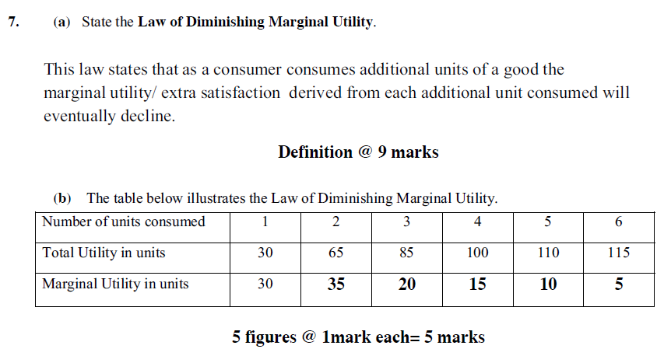
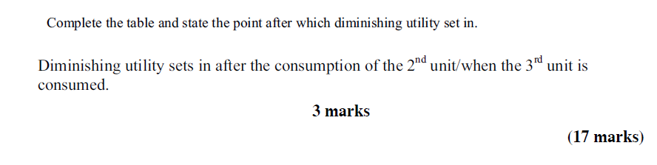

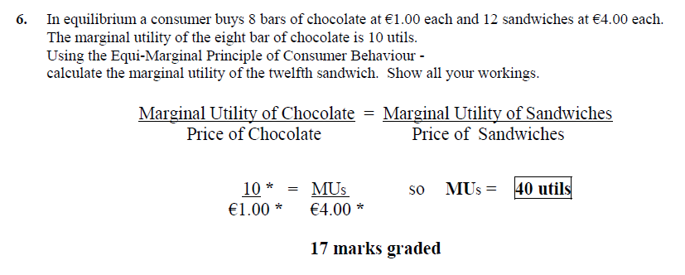

2005

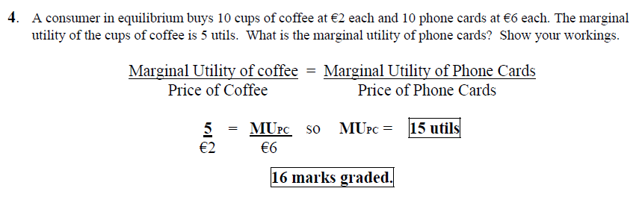

2004

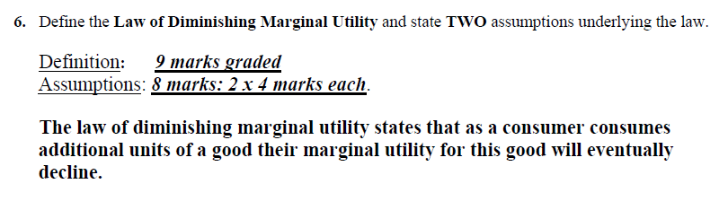
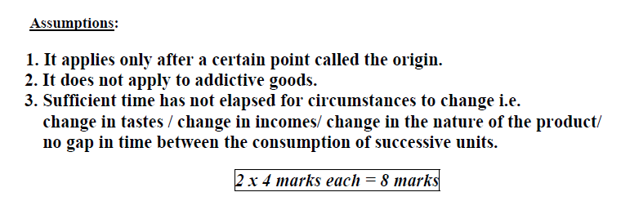

2003

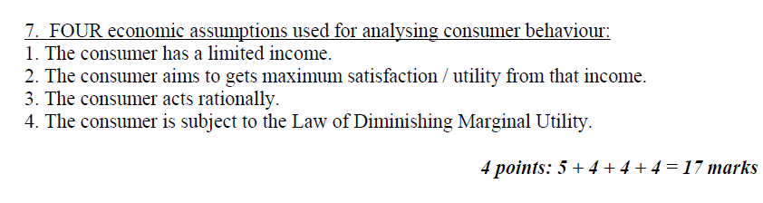

2002

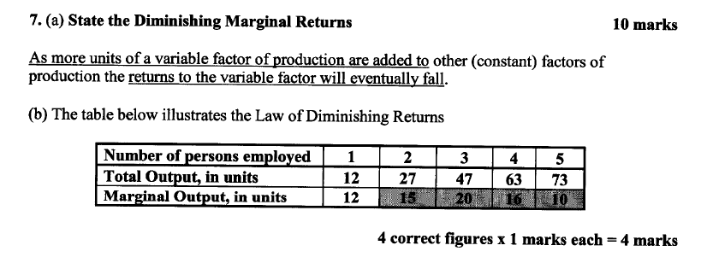
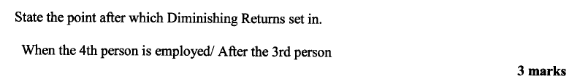

2000

8.
(a) Complete the following table:

No. persons employed | 1 | 2 | 3 | 4 | 5
Total Output in units | 10 | 25 | 42 | 58 | 62
Marginal Output in units | 10 | 15 | 17 | 16 | 4

(b) State at which point Diminishing Marginal Returns sets in:

When the 4th person produces less output than the 3rd person.

(c) Explain why Dimishing Marginal Returns occur:
Because the 4th person produces less than the 3rd person. This occurs as production will not continue to increase to the same level every time one person is taken on. This is due to constraints such as time limits on the day.

1999/1997 – Q1

State the law of Diminishing Marginal Utility.

This law states that as a consumer consumes additional units of a particular product, at some state the marginal utility derived from the consumption of that product will begin to decrease.

1995 – Q1

State the law of Equi Marginal Returns:

A consumer will be in equilibrium when he or she spends his or her income in such a way that the ratio of marginal utility to price is the same for all goods purchased.

