Exam Questions for The History of Economic Thought
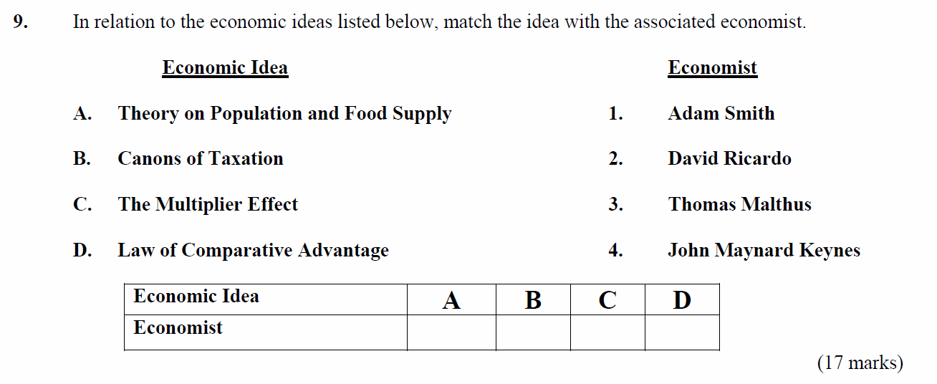
2007
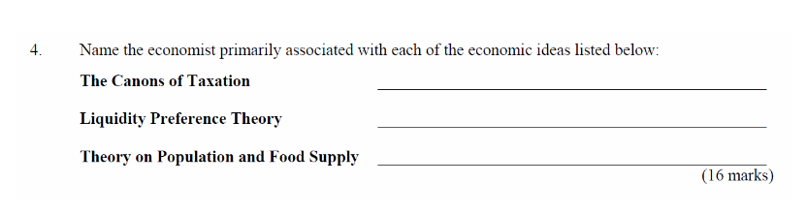
2006
2004
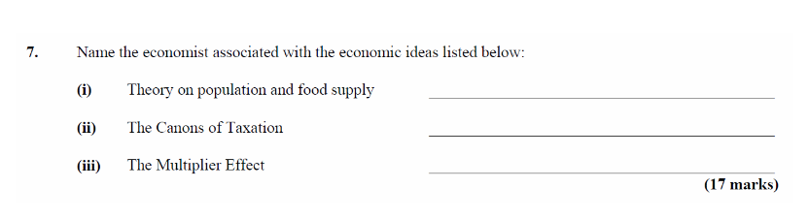
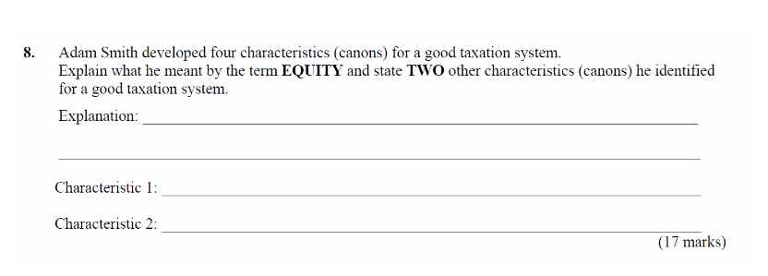
2003 & 2001
2010 Q 4 (b) (ii) The economist John Maynard Keynes developed the concept of the Multiplier to help understand how an economy works. Explain, using an example, the underlined term.

