LEAVING CERTIFICATE
MICRO-ECONOMICS
SUGGESTED
LONG TERM PLAN/SCHEME OF WORK

USING THIS RESOURCE
- Please use this resource at your own professional discretion.

- The resources in blue are on the DVD-ROM that was distributed at the national conference in 2013 and all resources will be uploaded to the PDST Economics website in due course.

- Please adapt this resource to meet the needs of your own school context by adding or deleting resources/methods as required.

- There are suggested literacy & numeracy strategies that you may need to adapt to suit your own school Improvement Plan.
Suggested DVD’s & documentaries

- The Ascent of Money
- The Love of Money
- Addicted to Money
- The Shock Doctrine
- Capitalism a love story
- The Corporation
- Animal Farm
- Civilization: The West & the Rest

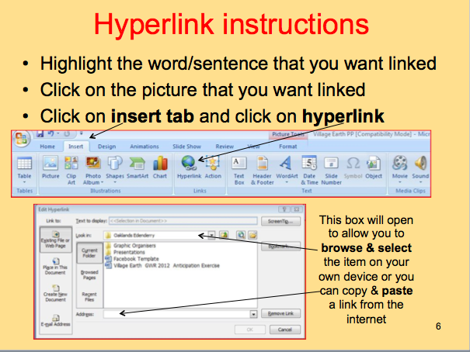
or
Studyclix OL
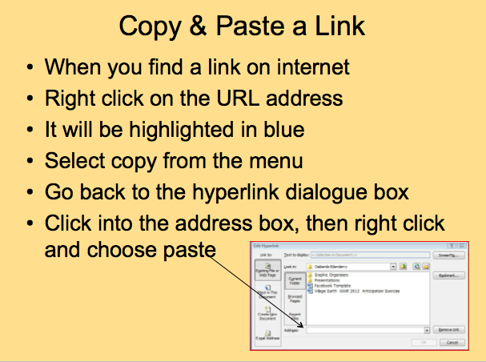Suggestedresources/activities & methods are constantly reviewed & updated
SLSS Graphic Organiser Booklet will be used throughout the course as a form of AfL along with, oral/written recap of previous lesson, use of lower, higher and open questions with built in wait time, observation of pair and share, tests using multiple choice, matching terms with pictures or explanations, calculations, and open questions, portfolio/project work to include research on internet, newspapers, preparing graphic organizers, flash cards & table quiz designed by students. Other AfL resources are available on the NCCA website.
A variety of appropriate methodologies will be used during each lesson including lecture, one to one, individual work, guided discovery, pair work, group work (3 to 4), jigsaw, placemat, my little book, student teaching & students creating on-line resources.
Comprehension strategies will include – KWHL, anticipation guides, visual verbal squares, skimming & scanning. Click here for further info.
Oral language will be developed through the use of think, pair & share, group work, oral presentations & debates.
Writing – high expectations will be set, use of editing checklist for spelling, punctuation & grammar, writing frames used for practicing exam questions.
Numeracy strategies will be integrated into lessons where appropriate eg. common use of calculators, key vocabulary, estimate/calculate/check, problem solving strategies (Fact Explain, Example Diagram (FEED) etc. , think/pair/share). Show me boards will be used to practice drawing diagrams. Interpretation of real life data.
LINKS TO CURRICULUM BASED RESOURCES |  | Links to up-to-date statistics | LINKS TO WEB 2.0 TOOLS FOR CREATING RESOURCES
pdsteconomics  Scoilnet.ie  Examinations.ie  Studyclix.com  e-xamit.ie  Economics help  (a to z glossary, notes etc.)  Economics basics | Punk Economics  60 second adventures in economics  Khan Academy  Share my lesson  http://www.tutor2u.net  Video tutorials  Economist free app  SBP free app | www.ntma.ie  www.cso.ie  www.financegov.ie  www.imf.ie  www.wto.ie  www.un.org | animoto.com (video)  Download Photostory (video)  Download Audacity  (sound recording) | Wordle.net (word cloud) Tagxedo.com (word cloud)  Studystack.com  (flashcards & games)  Quizlet.com  (flashcards, vocab)  Triptico  Freerice.com
KWHL - EXPLAINED
Pre-reading comprehension & Assessment for Learning (AfL) strategy
K | W | H | L
What do I know about this topic? | What do I want to know about this topic? | How do I find out more about this topic? | What have I learned about this topic?
EXAMPLE: ECONOMIC SYSTEMS
Is the way decisions are made in a country about:  What goods are to be produced?  How are these to be produced?  Who is to benefit from the production? | How many types of economic systems are there?  What are they called?  Which one is Ireland? | Reference  Book pages or handout numbers & dates  website urls  You Tube clips | There are three economic systems.  They are three  1. Free market/enterprise  2. Mixed economy  3. Centrally planned.  Ireland is a mixed economy
KWHL charts assist teachers in activating students' prior knowledge of a subject or topic and encourage inquisition, active reading, and research. They may also serve as an assessment of what students have learned during a unit of study. The K stands for what students know, the W stands for what students want to learn, the H stand for how they student will find out and the L stands for what the students learn as they read or research.
KWL creator is available @ tinyurl.com/kwlcreator
KWHL
Pre-reading comprehension & Assessment for Learning (AfL) strategy
K | W | H | L
What do I know about this topic? | What do I want to know about this topic? | How do I find out more about this topic? | What have I learned about this topic?
KWL creator is available @ tinyurl.com/kwlcreator
THINK-PAIR-SHARE
Think about the question on your own and write down your thoughts
Share your thoughts with your partner
Listen to your partner’s ideas
Combine your ideas
QUESTION | MY THOUGHTS/IDEAS | MY PARTNERS THOUGHTS/IDEAS | COMBINED IDEAS
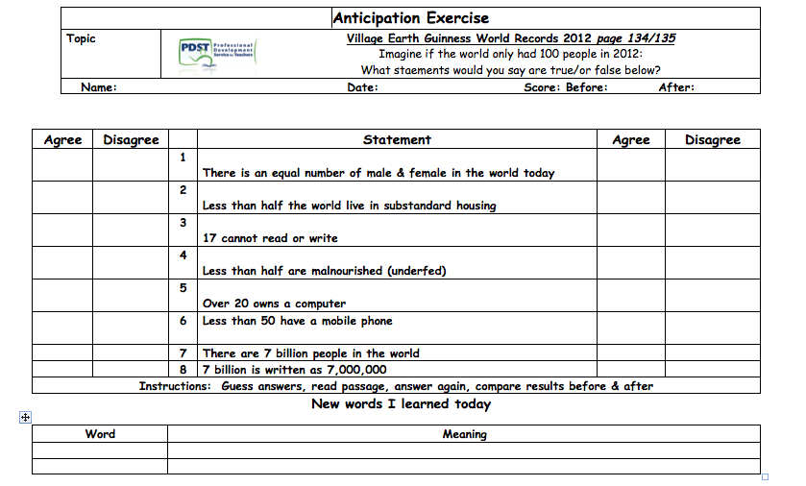

BLOOMS TAXONOMY OF CRITICAL THINKING
A |  | B |  | C
1 | 2 | 3 | 4 | 5 | 6
Knowledge/Remembering | Comprehension/  Understanding | Application | Analysis | Synthesis/Creating | Evaluation
Count  Choose  Define  Describe  Draw  Identify  Label  Match  Name  Outline  Quote  Read  Recall  Recite  Recognize  Record  Select  State  Write  5 Ws – who, what, where, why, when | Associate  Classify  Contrast  Compare  Compute  Convert  Defend  Demonstrate  Discuss  Distinguish  Estimate  Explain, Extend  Extrapolate  Generalize  Give examples  Infer  Interpret  Outline  Paraphrase, Predict  Rewrite, Rephrase  Summarise | Add  Apply  Build  Calculate  Change  Classify  Construct  Complete Demonstrate  Divide  Examine  Graph  Manipulate  Modify  Organise  Prepare  Produce  Present  Show  Solve  Use | Analyse  Arrange Breakdown Combine  Design  Detect  Develop  Diagram Differentiate Discriminate  Dissect  Examine  Illustrate  Infer  Investigate  Observe  Outline  Point out  Relate, Relationship  Select  Separate , Subdivide  Utilize | Categorize Combine  Compile  Compose  Create  Design  Devise  Generate  Invent  Imagine  Modify  Order  Organize  Plan  Rearrange Reconstruct Reorganize  Revise  Summarize Transform  Specify | Appraise  Assess  Compare  Conclude  Contrast  Criticize , Critique  Debate  Deduce  Determine  Disprove  Evaluate  Grade  Interpret  Judge , Justify  Measure  Opinion  Prove  Rank, Rate  Recommend  Support  Test
*List could be used as a verb in all levels – it is what you are asked to list that determines the level
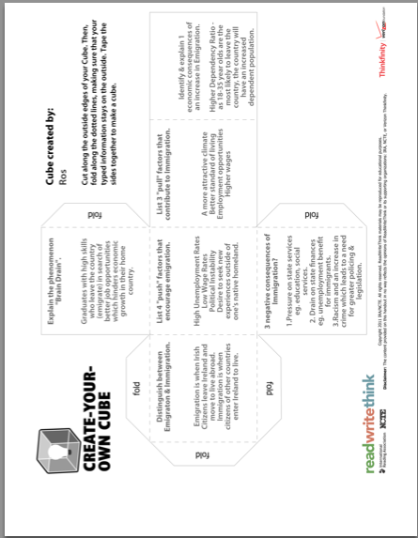

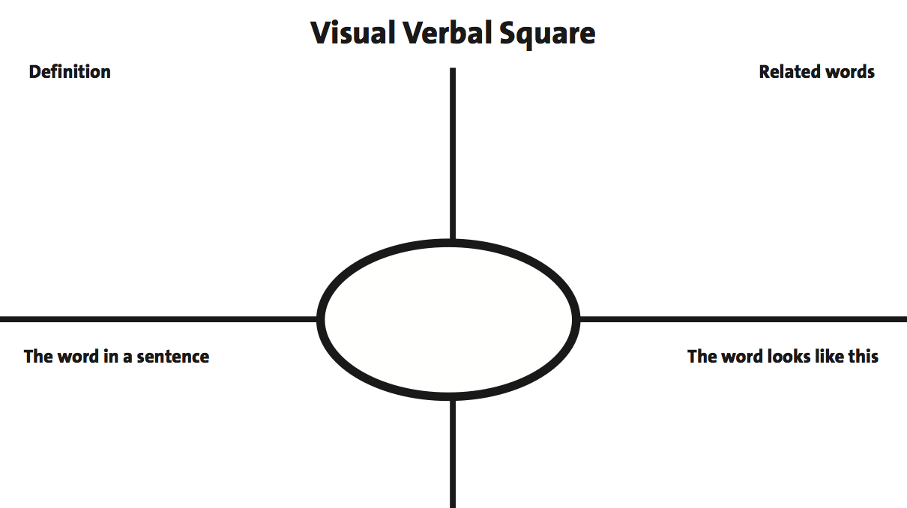

WORD CLOUDS - TAGXEDO.COM and WORDLE.NET

LEAVING CERTIFICATE ECONOMICS
MICRO TOPIC 1: INTRODUCTION TO ECONOMICS WEEK:
Differentiated  Expected Learning Outcomes  The students will be able to do the following:  Syllabus | Differentiated resources, methods & activities for AfL & AoL
 | General | Literacy  Comprehension, writing, oral language strategies  Numeracy  Language, estimation, problem solving strategies | Revision  &  AoL
- Understand the scope, purpose and limitations of economics as a science  - Understand economic concepts such as wealth, income, welfare, scarcity, choice, wants, needs, opportunity cost and factors of production  - Explain how economists draw up theories using Inductive and Deductive methods  - Identify the differences between factor, intermediate and final markets and give examples  - Differentiate between microeconomics and macroeconomics | Book page  Workbook page  Worksheet no>  Economic goods doc  What is wealth doc  Powerpoints  Introduction to economics  The economic problem  Why you study economics video | KWHL  KWL creator  pdsteconomics studystack (on-line games)  Q & A using Bloom’s prompts  Think-pair-share  My Little Book | Revision resources  Exam outcome verbs  Class tests  Collated SEC exams & schemes  STUDYCLIX HL  STUDYCLIX OL  Tony Buzan on mindmaps

LEAVING CERTIFICATE ECONOMICS
MICRO TOPIC 2: ECONOMIC SYSTEMS WEEK:
Differentiated  Expected Learning Outcomes  The students will be able to do the following:  Syllabus | Differentiated resources, methods & activities for AfL & AoL
 | General | Literacy  Comprehension, writing, oral language strategies  Numeracy  Language, estimation, problem solving strategies | Revision  &  AoL
- Differentiate between economic systems  - Identify and explain the advantages and disadvantages of economic systems  Discuss Smith, Keynes, Marx’s contribution to economic thought WRT economic systems | Book page  Workbook page  Worksheet no  Prezi presentation  Powerpoints  - Economic systems – includes links to Animal Farm, The Shock Doctrine, interviews with Milton Friedman & much more  - Game  - Student presentation  Invisible hand video | KWHL  KWL creator  pdsteconomics studystack  Cloze test doc  Matching doc  Q & A using Bloom’s prompts  Think-pair-share  Anticipation guide | Revision resources  Class tests  Collated SEC exams & schemes  Exam questions template doc  STUDYCLIX HL  STUDYCLIX OL
LEAVING CERTIFICATE ECONOMICS
MICRO TOPIC 3: THE CONSUMER & UTILITY (RATIONAL CHOICE THEORY) WEEK:
Differentiated  Expected Learning Outcomes  The students will be able to do the following:  Syllabus | Differentiated resources, methods & activities for AfL & AoL
 | General | Literacy  Comprehension, writing, oral language strategies | Numeracy  Language, estimation, problem solving strategies | Revision  &  AoL
- Define economic goods  - Explain the characteristics of economic good  - Explain and evaluate the assumptions underlying consumer behaviour  - Explain and illustrate the concept of utility  - Explain the concept of marginal utility  - Define and illustrate the law of diminishing marginal utility  - Explain and evaluate the assumptions underlying the law of diminishing marginal utility define and illustrate the principal of equi-marginal utility  - Calculate the marginal utility  Discuss Alfred Marshall’s contribution to economic thought WRT consumer & utility | Book page  Workbook page  Worksheet no  Economic goods doc  Powerpoints  The consumer & utility  DM utility clip  Consumer equilibrium clip  LDMR video clip  60 sec adventures in ec rational choice theory clip | KWHL  KWL creator  pdsteconomics studystack  Q & A using Bloom’s prompts  Think-pair-share  Anticipation guide | Calculate the marginal utility | Revision resources  Class tests  Collated SEC exams & schemes  Short questions doc  STUDYCLIX HL  STUDYCLIX OL
LEAVING CERTIFICATE ECONOMICS
MICRO TOPIC 4 : CONSUMER DEMAND (APPLICATION 1 OF RCT) WEEK:
Differentiated  Expected Learning Outcomes  The students will be able to do the following:  Syllabus | Differentiated resources, methods & activities for AfL & AoL
 | General | Literacy  Comprehension, writing, oral language strategies | Numeracy  Language, estimation, problem solving strategies | Revision  &  AoL
- Distinguish between individual demand and market/aggregate demand  - List and explain the determinants and influences of demand  - Explain a demand schedule and illustrate by means of a demand curve  - Demonstrate a change in any of the determinants of demand and interpret the outcomes using diagrams  Discuss Alfred Marshall’s contribution to economic thought WRT consumer demand | Book page  Workbook page  Worksheet no  Powerpoints  Demand  Student presentation  Movement & shifts video  Resources on scoilnet  Video how supply and demand affect the price of silver  video on supply and demand of water, oil, jeans | KWHL  KWL creator  pdsteconomics studystack  Q & A using Bloom’s prompts  Think-pair-share  Anticipation guide | Drawing diagrams  Labeling diagrams  Interpreting diagrams  Show-me board to practice drawing diagrams & AfL  Interactive demand curve  Worksheet | Revision resources  Class tests  Collated SEC exams & schemes  Exam questions template doc  STUDYCLIX HL  STUDYCLIX OL  Demand recap video
LEAVING CERTIFICATE ECONOMICS
MICRO TOPIC 5: PRODUCER SUPPLY (APPLICATION 2 OF RCT) WEEK:
Differentiated  Expected Learning Outcomes  The students will be able to do the following:  Syllabus | Differentiated resources, methods & activities for AfL & AoL
 | General | Literacy  Comprehension, writing, oral language strategies | Numeracy  Language, estimation, problem solving strategies | Revision  &  AoL
- Distinguish between individual supply and market/aggregate supply  - List and explain the determinants and influences of supply  - Explain the supply schedule and illustrate by means of a supply curve  - Demonstrate a change in any of the determinants of supply and interpret the outcome using diagrams  Explain Say’s Law | Book page  Workbook page  Worksheet no  Powerpoints  Supply  Student presentation  Supply video  Supply video 2  Movements & shifts in supply curves (scoilnet) | KWHL  KWL creator  pdsteconomics studystack  Q & A using Bloom’s prompts  Think-pair-share | Drawing diagrams  Labeling diagrams  Interpreting diagrams  Show-me board to practice drawing diagrams & AfL | Revision resources  Class tests  Collated SEC exams & schemes  STUDYCLIX HL  STUDYCLIX OL
LEAVING CERTIFICATE ECONOMICS
MICRO TOPIC 6: THE MARKET MECHANISM (APPLICATION 3 OF RCT) WEEK:
Differentiated  Expected Learning Outcomes  The students will be able to do the following:  Syllabus | Differentiated resources, methods & activities for AfL & AoL
 | General | Literacy  Comprehension, writing, oral language strategies | Numeracy  Language, estimation, problem solving strategies | Revision  &  AoL
- Explain and illustrate, by means of a diagram, equilibrium price and equilibrium quantity  - Apply the tools of demand and supply analysis to price and quantity changes in markets  Discuss Alfred Marshall’s contribution to economic thought WRT the market mechanism | Book page  Workbook page  Worksheet no  Powerpoints  Business 2,000 quiz  Quiz on supply & demand | KWHL  KWL creator  pdsteconomics studystack  Q & A using Bloom’s prompts  Think-pair-share | Drawing diagrams  Labeling diagrams  Interpreting diagrams  Show-me board to practice drawing diagrams & AfL | Revision resources  Class tests  Collated SEC exams & schemes  STUDYCLIX HL  STUDYCLIX OL
LEAVING CERTIFICATE ECONOMICS
MICRO TOPIC 7: THE FACTOR MARKETS (APPLICATION 4 OF RCT) WEEK:
Differentiated  Expected Learning Outcomes  The students will be able to do the following:  Syllabus | Differentiated resources, methods & activities for AfL & AoL
 | General | Literacy  Comprehension, writing, oral language strategies | Numeracy  Language, estimation, problem solving strategies | Revision  &  AoL
- Define each of the factors of production  - Illustrate and explain the concept of derived demand  - Understand the concepts of marginal revenue productivity (MRP) and marginal physical productivity (MPP)  - Examine the factors that affect MRP and MPP  - Understand that the demand curve for a factor of production is its MRP curve  - Apply MRP theory to both perfect competition and monopoly/imperfect competition  - Illustrate the concepts of supply price, economic rent, quasi economic rent and transfer prices | Book page  Workbook page  Worksheet no  Powerpoints  FOP matching exercise | KWHL  KWL creator  pdsteconomics studystack  Q & A using Bloom’s prompts  Think-pair-share  Visual verbal square |  | Revision resources  Class tests  Collated SEC exams & schemes  STUDYCLIX HL  STUDYCLIX OL
LEAVING CERTIFICATE ECONOMICS
MICRO TOPIC 8: FACTORS OF PRODUCTION – LAND WEEK:
Differentiated  Expected Learning Outcomes  The students will be able to do the following:  Syllabus | Differentiated resources, methods & activities for AfL & AoL
 | General | Literacy  Comprehension, writing, oral language strategies | Numeracy  Language, estimation, problem solving strategies | Revision  &  AoL
- Define land as a factor of production  - Give examples of land and state how they contribute to the production of wealth  - Explain the economic characteristics of land  - Explain why land is a unique factor of production  - Explain why the demand for land is a derived demand  - Illustrate and explain the concept of economic rent  - Explain the factors that influence the price paid for land  - Describe the factors that determine the location of a factory  - Explain the factors leading to the price of property increasing/decreasing in Ireland  Discuss RICARDO’S contribution to economic thought | Book page  Workbook page  Worksheet no  Powerpoints  Land  Sliderocket (NK)  Land  Sliderocket (NK)  Irelands property crash  Scoilnet Quiz | KWHL  KWL creator  pdsteconomics studystack  Q & A using Bloom’s prompts  Think-pair-share | Drawing diagrams  Labeling diagrams  Interpreting diagrams  Show-me board to practice drawing diagrams & AfL | Revision resources  Class tests  Collated SEC exams & schemes  Exam questions template doc  STUDYCLIX HL  STUDYCLIX OL
LEAVING CERTIFICATE ECONOMICS
MICRO TOPIC 8: FACTORS OF PRODUCTION – LABOUR WEEK:
Differentiated  Expected Learning Outcomes  The students will be able to do the following:  Syllabus | Differentiated resources, methods & activities for AfL & AoL
 | General | Literacy  Comprehension, writing, oral language strategies | Numeracy  Language, estimation, problem solving strategies | Revision  &  AoL
- Define labour  - Illustrate and explain the concept of derived demand  - Understand MRP and MPP as they relate to labour  - Examine the factors that affect the demand for labour by an individual firm  - Illustrate by means of a diagram the relationship between the wage rate and quantity demanded of labour  - Illustrate by means of a diagram the relationship between the wage rate and the quantity supplied of labour  - Examine the factors affecting the mobility of labour  - Define geographical mobility and occupational mobility of labour  - Illustrate and interpret the backward bending supply curve of labour  - Illustrate and explain equilibrium wage level  - Examine the reasons for differences in wage rates  - Examine what factors make labour efficient.  DISTINGUISH BETWEEN Smith & Marx labour theory of vaue | Book page  Workbook page  Worksheet no  Powerpoints  Labour  Student presentation | KWHL  KWL creator  pdsteconomics studystack  Q & A using Bloom’s prompts  Think-pair-share | Drawing diagrams  Labeling diagrams  Interpreting diagrams  Show-me board to practice drawing diagrams & AfL | Revision resources  Class tests  Collated SEC exams & schemes  Exam questions template doc  STUDYCLIX HL  STUDYCLIX OL
LEAVING CERTIFICATE ECONOMICS
MICRO: TOPIC 9: FACTORS OF PRODUCTION – CAPITAL WEEK:
Differentiated  Expected Learning Outcomes  The students will be able to do the following:  Syllabus | Differentiated resources, methods & activities for AfL & AoL
 | General | Literacy  Comprehension, writing, oral language strategies | Numeracy  Language, estimation, problem solving strategies | Revision  &  AoL
- Define capital and explain why interest is the return  - Examine why capital is needed in an economy  - Explain the different types of capital  - Illustrate an understanding of marginal efficiency of capital  - Explain the factors that influence marginal efficiency of capital  - Compare capital widening and capital deepening  - Define savings and stage those who save in society  - Explain the factors that influence the level of savings  - Evaluate why savings are important  - Define investment  - State the factors that influence the level of investment in an economy  - Examine why investment is important in an economy  - Explain the loanable funds theory of interest rates  - Explain the Keynesian theory of interest rates  Discuss Keynes & Marx’s contribution to economic thought WRT capital | Book page  Workbook page  Worksheet no  Powerpoints  Capital | KWHL  KWL creator  pdsteconomics studystack  Q & A using Bloom’s prompts  Think-pair-share |  | Revision resources  Class tests  Collated SEC exams & schemes  Exam questions template doc  STUDYCLIX HL  STUDYCLIX OL  mindmap

LEAVING CERTIFICATE ECONOMICS
MICRO TOPIC 10: FACTORS OF PRODUCTION – ENTERPRISE WEEK:
Differentiated  Expected Learning Outcomes  The students will be able to do the following:  Syllabus | Differentiated resources, methods & activities for AfL & AoL
 | General | Literacy  Comprehension, writing, oral language strategies | Numeracy  Language, estimation, problem solving strategies | Revision  &  AoL
- Explain profit, supernormal profit, enterprise and entrepreneur  - Identify different risk-takers in the economy  - Explain why enterprise is a unique factor of production  - Understand the role of profit in an economy  - Examine the role that entrepreneurs play in an economy  - Identify the risks taken by businesses  - Apply the concept of economic rent to enterprise | Book page  Workbook page  Worksheet no  Powerpoints  Enterprise & economic Rent | KWHL  KWL creator  pdsteconomics studystack  Q & A using Bloom’s prompts  Think-pair-share | Calculating economic rent & transfer earnings | Revision resources  Class tests  Collated SEC exams & schemes  Exam questions template doc  STUDYCLIX HL  STUDYCLIX OL
LEAVING CERTIFICATE ECONOMICS
MICRO TOPIC 11: ELASTICITY WEEK:
Differentiated  Expected Learning Outcomes  The students will be able to do the following:  Syllabus | Differentiated resources, methods & activities for AfL & AoL
 | General | Literacy  Comprehension, writing, oral language strategies | Numeracy  Language, estimation, problem solving strategies | Revision  &  AoL
- Explain the concept of elasticity  - Explain price elasticity of demand (PED)  - Calculate PED from given data using the supplied formula and interpret values for PED  - Understand the usefulness of a knowledge of PED to the consumer, producer and government  - Explain the factors that determine the PED of a good  - Apply a knowledge of price elasticity to determine the effect of a change in price on a firm’s revenue and profits  - Explain cross elasticity of demand (CED)  - Calculate CED from given data using the supplied formula and interpret values for CED (substitute goods and complementary goods)  - Understand the significance of a knowledge of CED to a firm  - Explain income elasticity of demand (YED)  - Calculate YED from given data using the supplied formula and interpret values for YED (normal goods and inferior goods)  - Apply a knowledge of income elasticity to determine the effect of a change in income on a firm’s sales  - Explain price elasticity of supply (PES)  - Calculate PES from given data using the supplied formula and interpret values for PES  - Explain the factors that affect the PES of a good  Discuss Alfred Marshall’s contribution to economic thought WRT elasticity | Book page  Workbook page  Worksheet no  Powerpoints  Elasticity of demand  Elasticity of supply  Student presentations  WWTBAM on elasticity  Resources on scoilnet  Quiz on PED  Elasticity of demand video | KWHL  KWL creator  pdsteconomics studystack  Q & A using Bloom’s prompts  Think-pair-share | Drawing diagrams  Labeling diagrams  Interpreting diagrams  Calculating  PED  YED  CED  Show-me board to practice drawing diagrams & AfL | Revision resources  Class tests  Collated SEC exams & schemes  Exam questions template & answers doc  STUDYCLIX HL  STUDYCLIX OL
LEAVING CERTIFICATE ECONOMICS
MICRO: TOPIC 12: COSTS WEEK:
Differentiated  Expected Learning Outcomes  The students will be able to do the following:  Syllabus | Differentiated resources, methods & activities for AfL & AoL
 | General | Literacy  Comprehension, writing, oral language strategies | Revision  &  AoL
- Explain the short run period  - Explain the long run period  - Define implicit, explicit and opportunity cost  - Define, apply and interpret the law of diminishing returns  - Explain, calculate and illustrate average fixed cost, average variable cost and average total cost  - Explain, calculate and illustrate total, average and marginal revenue and marginal cost  - Define and illustrate total profit and normal profit  - Derive and illustrate the SRAC (or SAC) and account for its shape  - Define and identify the point of optimum production  - Derive and illustrate the LRAC and account for its shape  - Analyse the reasons why businesses grow (economies of scale) and the constraints on growth (diseconomies of scale)  - Examine the economic reasons for the survival of small firms in the Irish economy  - Explain social costs and benefits  - Analyse the short and long run profit-maximising conditions of a firm | Book page  Workbook page  Worksheet no  Powerpoints  Costs  Costs of production (student presentation) | KWHL  KWL creator  pdsteconomics studystack  Q & A using Bloom’s prompts  Think-pair-share  Numeracy  Drawing diagrams  Labeling diagrams  Interpreting diagrams  Calculating FC, VC, AC, MC,  Diminishing Marginal Returns,  TR, AR, MR | Revision resources  Class tests  Collated SEC exams & schemes  STUDYCLIX HL  STUDYCLIX OL
LEAVING CERTIFICATE ECONOMICS
MICRO TOPIC 13: MARKET STRUCTURES - PERFECT COMPETITION WEEK:
Differentiated  Expected Learning Outcomes  The students will be able to do the following:  Syllabus | Differentiated resources, methods & activities for AfL & AoL
 | General | Literacy  Comprehension, writing, oral language strategies | Numeracy  Language, estimation, problem solving strategies | Revision  &  AoL
- Explain, with examples, the theory of perfect competition  - Describe and assess the assumptions underlying perfect competition  - Illustrate, explain and interpret a firm’s demand curve  - Describe the equilibrium for a perfectly competitive firm in the short run  - Define and illustrate supernormal profits  - Discuss why new firms enter the industry  - Critically analyse the effects on equilibrium of new entrants  - Describe, with the aid of a diagram, the equilibrium for a perfectly competitive firm in the long run  - Derive the supply curve for a perfectly competitive firm  - Analyse perfect competition as a market from the point of view of consumers, producers and the use of scarce resources and as a model in understanding market structures | Book page  Workbook page  Worksheet no  Competition made simple doc  Powerpoints  Drawing diagrams  Perfect competition  Student presentation | KWHL  KWL creator  Studystack  Q & A using Bloom’s prompts  Think-pair-share | Drawing diagrams  Labeling diagrams  Interpreting diagrams  Show-me board to practice drawing diagrams & AfL | Revision resources  Class tests  Collated SEC exams & schemes  Exam question template doc  STUDYCLIX HL  STUDYCLIX OL
LEAVING CERTIFICATE ECONOMICS
MICRO TOPIC 14: MARKET STRUCTURES – MONOPOLY WEEK:
Differentiated  Expected Learning Outcomes  The students will be able to do the following:  Syllabus | Differentiated resources, methods & activities for AfL & AoL
 | General | Literacy  Comprehension, writing, oral language strategies | Numeracy  Language, estimation, problem solving strategies | Revision  &  AoL
- Explain, with examples, the theory of monopoly  - Describe and assess the assumptions underlying monopoly  - Illustrate and explain the firm’s demand curve under monopoly  - Describe, with the aid of a diagram, the equilibrium for a monopolist  - Define and illustrate supernormal profits  - Explain and illustrate profit-maximising output/price  - Critically analyse monopoly as a market form from the point of view of consumers, producers and the use of scarce resources  - Suggest ways as to how state monopolies could be made more effective  - Compare and contrast the long run equilibrium position of perfect competition, monopoly and imperfect competition  - Discuss the conditions necessary for price discrimination.  - Distinguish between different types of price discrimination | Book page  Workbook page  Worksheet no  Powerpoints  Monoploy  Price discrimination  Youtube 7:01 - Barriers  Monopoly video  Price discrimination clip  Price discrimination graphic organiser  Price discrimination summary | KWHL  KWL creator  pdsteconomics studystack  Q & A using Bloom’s prompts  Think-pair-share | Drawing diagrams  Labeling diagrams  Interpreting diagrams  Show-me board to practice drawing diagrams & AfL | Revision resources  Class tests  Collated SEC exams & schemes  Exam question template & solutions doc  STUDYCLIX HL  STUDYCLIX OL
LEAVING CERTIFICATE ECONOMICS
MICRO TOPIC 14: MARKET STRUCTURES – OLIGOPOLY WEEK:
Differentiated  Expected Learning Outcomes  The students will be able to do the following:  Syllabus | Differentiated resources, methods & activities for AfL & AoL
 | General | Literacy  Comprehension, writing, oral language strategies | Numeracy  Language, estimation, problem solving strategies | Revision  &  AoL
- Explain, with examples, the theory of oligopoly  - Describe the assumptions underlying oligopoly  - Illustrate and explain the kinked demand curve  - Describe the relationship between the demand and marginal revenue curves  - Describe the long run equilibrium of an oligopolistic firm  - Explain rigidity of prices  - Explain the types of collusion that may occur in this market  - Explain why firms may pursue goals other than profit maximisation  - Explain price and non-price competition  - Describe price leadership | Book page  Workbook page  Worksheet no  Powerpoints  Oligopoy  Oligopoly video  Microsoft V Apple video  Imperfect v oligopoly video | KWHL  KWL creator  pdsteconomics studystack  Q & A using Bloom’s prompts  Think-pair-share | Drawing diagrams  Labeling diagrams  Interpreting diagrams  Show-me board to practice drawing diagrams & AfL | Revision resources  Class tests  Collated SEC exams & schemes  Exam question template & solutions doc  STUDYCLIX HL  STUDYCLIX OL
LEAVING CERTIFICATE ECONOMICS
MICRO TOPIC 15: MARKET STRUCTURES - IMPERFECT COMPETITION WEEK:
Differentiated  Expected Learning Outcomes  The students will be able to do the following:  Syllabus | Differentiated resources, methods & activities for AfL & AoL
 | General | Literacy  Comprehension, writing, oral language strategies | Numeracy  Language, estimation, problem solving strategies | Revision  &  AoL
- Explain, with examples, the theory of imperfect competition  - Describe the assumptions underlying imperfect competition  - Illustrate and explain the firm’s demand curves  - Describe the equilibrium for an imperfectly competitive firm in the short run  - Define and illustrate supernormal profits  - Discuss why new firms may enter the industry  - Analyse the effects on equilibrium of new entrants  - Describe, with the aid of a diagram, the equilibrium for an imperfectly competitive firm in the long run  - Illustrate and explain profit-maximising output/price  - Analyse perfect competition as a market form from the point of view of consumers, producers and the use of scarce resources | Book page  Workbook page  Worksheet no  Powerpoints  Imperfect competition  Monopolistic competition video  Scoilnet Quiz  Perfect V imperfect video  Imperfect v oligopoly video | KWHL  KWL creator  pdsteconomics studystack  Q & A using Bloom’s prompts  Think-pair-share | Drawing diagrams  Labeling diagrams  Interpreting diagrams  Show-me board to practice drawing diagrams & AfL | Revision resources  Class tests  Collated SEC exams & schemes  STUDYCLIX HL  STUDYCLIX OL  Market stuctures grid for revision

