Geoecology – Three Essays in Section – Choose One – Each essay 80 marks

Sample Geography Paper
16. Assess the global implications of the continued felling of tropical rainforests.
17. Examine how human activities can accelerate soil erosion.
18. Illustrate the development of biomes, with reference to a specific example.
2006
16. Examine the factors that influence soil characteristics.
17. Examine the main characteristics of a biome that you have studied.
18. Assess the impact of human activity on a biome that you have studied.
2007
16. Examine how over-cropping / over-grazing and desertification can affect soils.
17. Examine the general composition and characteristics of any one soil type that you have studied.
18. Describe how plant and animal life adapt to soil and climatic conditions in a biome which you have studied.
2008
16. Examine two ways in which human activities have altered the natural characteristics of a biome that you have studied.
17. Examine two of the natural processes which influence soil formation.
18. Describe and explain the main characteristics of one biome that you have studied.
2009
16. With reference to one soil type you have studied, examine how parent material, climate and organic matter influence the soil.
17. Discuss how human activities can accelerate soil erosion.
18. Assess how biomes have been altered by human activity.
2010
16. Examine the influence of climate on the characteristics of one biome that you that have
studied.
17. Examine two ways in which human activities have impacted on soils.
18. Describe and explain the characteristics of any one soil type studied by you.

Marking Scheme 2011
16. Soil characteristics are affected by their immediate environment and by a combination of
processes operating in that environment.
Examine any three soil processes that affect soil characteristics.
Number of aspects: 3 @ 27 + 27 + 26
Identifying aspect: 4 marks
Discussion: 8 x SRPs
Overall coherence: 7/6 marks graded
➢ Allow for up to 2 examples to a max of 2 SRPs (different examples and in different aspects)
➢ Allow for up to 2 illustrations to a max of 2SRPs (different illustrations and in different aspects).

17. Examine the characteristics of any one biome that you have studied under three of the
following headings:
➢ Climate
➢ Soils
➢ Flora
➢ Fauna.
Number of aspects: 3 @ 27 + 27 + 26
Identifying aspect: 4 marks
Discussion: 8 x SRPs
Overall coherence: 7/6 marks graded
➢ Allow for up to 2 examples to a max of 2 SRPs (different examples and in different aspects)
➢ Allow for up to 2 illustrations to a max of 2SRPs (different illustrations and in different aspects).

18. The development of economic activities can alter biomes.
Discuss this statement with reference to appropriate examples that you have studied.
Number of aspects: 3 @ 27 + 27 + 26 4 @ 20 marks each
Identifying aspect: 4 marks 4 marks
Discussion: 8 x SRPs OR 6 x SRPs
Overall coherence: 7/6 marks graded 4 marks graded
➢ Select scheme according to number of aspects discussed
➢ Allow for up to 2 examples to a max of 2 SRPs (different examples and in different aspects)
➢ Allow for up to 2 illustrations to a max of 2SRPs (different illustrations andin different aspects).

Note: It is better to discuss three or four aspects of the theme in some detail, rather than to give a
superficial treatment of a large number of points.

Do not worry we will practice this method of writing an essay to get maximum marks.
There are always three essays to choose one from.

Biomes –

Here are some web sites where you can do some further investigation of soils and biomes.
Chapter 7.1: Soils
Soils (general):
http://encarta.msn.com/encyclopedia_761576446/Soil.html
http://www.skoool.ie/skoool/homeworkzone.asp?id=3542
Soil Composition:
http://library.thinkquest.org/J003195F/soil1.htm
Soil Characteristics:
http://www.ucopenaccess.org/courses/APEnvSciv2/course%20files/readings/lesson52/text01.htm
Soil-forming Factors:
http://www.uwsp.edu/geo/faculty/ritter/geog101/textbook/soil_systems/soil__development_soil_forming_factors.html
http://soil.gsfc.nasa.gov/soilform/parmat.htm
Soil-forming Processes:
http://www.uwsp.edu/geo/faculty/ritter/geog101/textbook/soil_systems/soil_development_processes.html
http://www.physicalgeography.net/fundamentals/10u.html
Brown Earth Soils:
http://www.macaulay.ac.uk/soilposters/2.pdf
http://www.answers.com/topic/brown-earth?cat=technology
Soil in the Sahel:
http://www.eden-foundation.org/project/desertif.html
http://www.angelfire.com/mac/egmatthews/worldinfo/africa/sahel.html

Chapter 7.2: Biomes.
Introduction to Biomes:
http://www.runet.edu/~swoodwar/CLASSES/GEOG235/biomes/intro.html
Desert Biomes:
http://www.ucmp.berkeley.edu/exhibits/biomes/deserts.php
http://www.desertusa.com/desert.html
Origin of Deserts:
http://everything2.com/index.pl?node=desert
Deserts of North America:
http://www.desertusa.com/du_mojave.html
http://mojavedesert.net/description.html
http://pubs.usgs.gov/gip/deserts/types/
Altering the Californian Biome:
http://www.forestsforever.org/act.html
http://calag.ucop.edu/0701JFM/resup02.html
http://www.agclassroom.org/kids/stats/california.pdf
http://www.californiahistory.org/

Introduction to Biomes.

Remember the questions from the start of the previous section.
- Describe how plant and animal life adapt to soil and climatic conditions in a biome which you have studied.
- Assess the impact of human activity on a biome that you have studied.
- Examine the main characteristics of a biome that you have studied.
- Assess how biomes have been altered by human activity.

Answering the Option Question is different to the other answers
- The option answer is an essay type answer
- Usually the marking scheme looks for three aspects to be discussed
- Therefore within the answer there should be three main paragraphs = 80/3 = 27 +27+26
- Each paragraph is worth 27 marks, broken up as follows –
Identifying aspect - 4 marks
8 x SRP’s 16 marks
Cohesive structure/well written 7 marks
Total per paragraph 27 marks

Biome - Definition

- The biome is the largest ecosystem unit
- Each biome takes its name from the dominant type of vegetation found within it.
- Usually climate has been the major controlling factor – though economic development has changed many of the natural systems
- There are four main factors which combine to produce each biome
    - Climate
    - Soils
    - Natural Vegetation
    - Animal Life
- Examples of biomes include
    - Tropical Rainforest
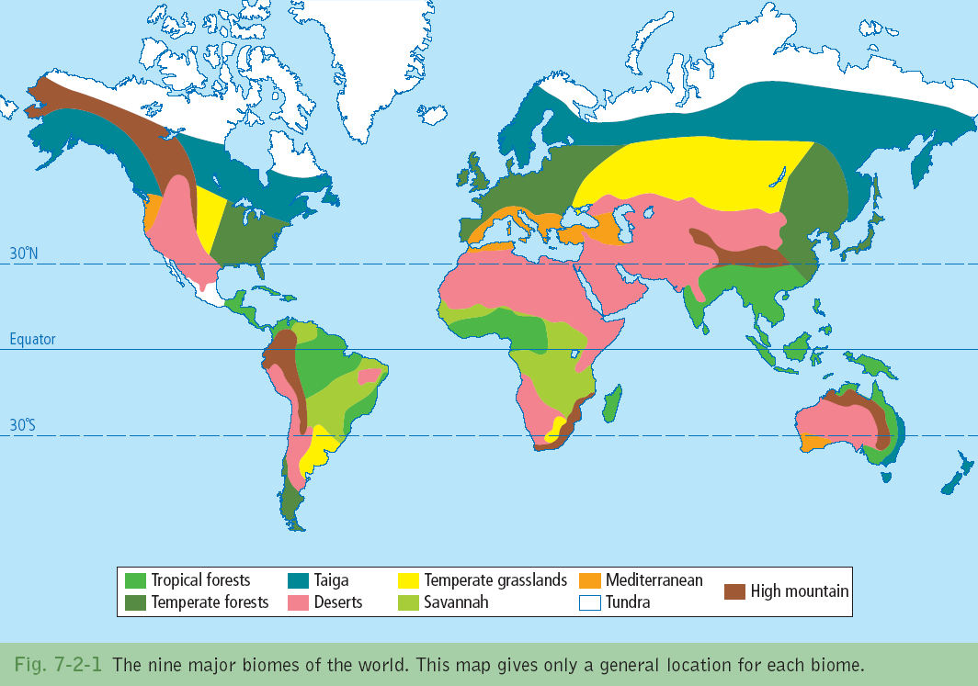
    - Desert
    - Mediterranean

For the purpose of this section, we will study a Desert Biome. This is the biome that is found a portion of the South West US region.

North American Deserts
Read page 171 and answer the following questions
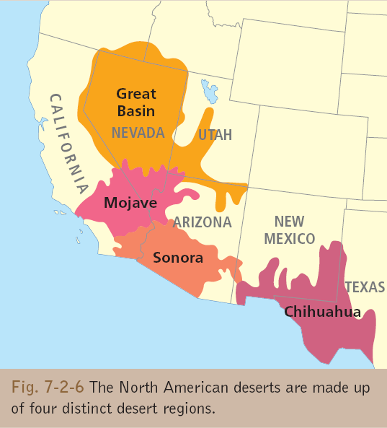

- Name the four distinct desert regions.

_______________________________
- State the location of the desert.

_______________________________
- State the size of the desert

_______________________________
- Why is the Great Basin considered a cold desert?

_______________________________

Climate a Characteristic of Desert Regions

- Rainfall is usually v low and unpredictable. Short bursts of rain that are not easily absorbed into the ground. This is due to the high rate of evaporation. Rainfall has therefore a minimal effect on vegetation growth.
- Annual rainfall in the hot desert regions varies between 150mm and 300 mm per year. The Cold Desert receives 300mm of precipitation throughout the year. This falls as snow during the winter months.
- The temperature range in the deserts is extreme. Diurnal range is often greater than 30˚C. Annual temperature range is between 20˚C and 30˚C. ‘Night is the winter of the desert’.
- Due to the latitudes, by day the sun is high in the sky, shining vertically on the barren region. With little vegetation and cloud cover very little heat is lost and most is absorbed by the stony surfaces. The temperature can climb to 45˚C.
- Night time, temperatures plummet due to the absence of cloud cover and vegetation. The temperature can fall below freezing point.

Soil - A Characteristic of Desert Regions

- Dominant soil is Aridsols in this region. Aridsols range from sand and fine textured to gravelly and coarse textured. Soils have been eroded and washed down from mountainous areas during repeated downpours over 1,000’s of years.
- Lower slopes have coarse textured soils. These are well drained due to their texture. There is a deep soil cover of fine soil but this cover is susceptible to erosion if winds are strong as fine particles can be borne in the wind.
- Composition Aridsols have a low percentage of organic matter due to the sparse vegetation cover. There is very little humus in the upper horizon of the soil which means that the soil does not have a visible A horizon. The soil tend to have a light grey colour also due to the absence of dark coloured humus.
- Nutrients Due to the mineral content of the soil the soil has many nutrients. This is evident when plants grow rapidly after a downpour. However, due to lack of vegetation and humus in the soil, the soil cannot retain the moisture it receives from as a result of precipitation and it is lost through intense evaporation.
- Salinisation occurs as a result of the arid conditions. Moisture moves up through the soil by capillary action. Dissolved salts are brought back to the surface creating saltpans on the surface. These poison the soil and totally restrict growth.
- Calcification can also occur as a result of the vertical movement of moisture. A hardpan layer of calcite builds up in the lower soil horizons. This prevents roots from penetrating the soil and creates hard areas within the soil.

Adaptation of Plant Life to Soil and Climatic Conditions

- Fast growing plants are supported due to the availability of moisture in the soil for short periods of time. These ephemerals complete their life cycle in a short 2-3 week period. This occurs following heavy showers of rain. The seeds have a waxy coating which ensures that the seeds can survive many years if necessary. Examples of these include the Desert Paintbrush and Creosote Bush.
- Succulent plants store water for long periods. They store water during wet periods in their structure, this can include tap roots, stems or spines. The plants swell up when they absorb water and appear to shrink as water is lost. Examples include the Joshua Tree and varieties of the Yucca plant.
- Large root systems provide plants with the opportunity to absorb large amounts of water when it rains. The roots are close to the surface and spread outwards. The Giant Saguaro Cactus has a shallow root system.
- The Mesquite has long taproots reaching up to 50 ms which allows the plant reach deep underground in search of moisture.
- Defensive systems such as unpleasant smells and tastes are another way that plants have adapted to the harsh soil and climatic conditions. The Creosote bush produces toxins if an animal attacks it.
- The spiky leaves and spines found on a cactus stop creatures eating its succulent flesh and hence its water supply. These also reduce evaporation in the intense heat.

Adaptation of Animal Life to Soil and Climatic Conditions

- Animals are nocturnal. Animals such as the rattle snake and elf owl are only active in the morning or evening.
- Animals burrow into the ground to escape the heat. Tarantulas hide in the ground during the hottest parts of the day and come out to hunt and feed when the desert is cooler.
- Insects use the shade of twigs to stay out of the direct glare of the sun. The Jackrabbit shades under the larger Joshua Tree and moves with the shadow to keep out of the sun.
- Many desert animals have paler skin/fur than other varieties of their species. This makes the animal less obvious to predators and assists the animal in absorbing less heat.
- Animals such as the jackrabbit have developed long body parts to lose some of their body heat. The jackrabbit has extremely long ears.
- Animals such as the squirrel hibernate during the extremely hot summer season.
- The road runner, a bird typical of the North American desert, runs instead of flying, thus preserving most of its energy. (and keeping ahead of the coyote)

Answer this question-. Describe how plant and animal life adapt to soil and climatic conditions in a biome which you have studied. Throughout the answer keep on referring back to the question. Use linking statements such as – ‘In order to best describe how the vegetation and fauna have adapted to the North American Desert, it is essential to describe the soil and climatic conditions of the region.’ Or ‘This is another example of how plant life in this biome has adapted to the soil conditions’.

The Impact of Human Activity on a Biome

A biome that has been greatly impacted by Human Activity is the Desert Biome of California.

Prior to the gold rush of the 1850's this area was not densely populated. It was home to Native Americans and those descendents of Spanish expedititions. However since the Gold Rush of the 1850's the tide of immigration continues into the state of California. The motto of the State of California is Eureka, meaning we found it referring to the discovery of Gold in the State. It is also known as the Gold State.

Deforestation

- California's forests of Giant Redwood Trees have been decimated since the Goldrush. There is only 4% of the original stock of forests remaining. The Giant Redwood was seen as the most hard wearing and were used before the forests of oaks and pines.
- Lumber from the trees was the first building material to be produced industrially in Northern California.
- Sawmills were established throughout the region to process the wood from forests.
- Wood was originally used to support mines, used as pit props.
- Wood was used to build mining towns, agricultural towns and commercial centres.
- The building of railways meant that lumber could be transported as far south as San Francisco. Forests were cleared for railway lines and farmland.
- The forested areas were replaced by towns and cities built by the wood that once naturally grew there.
- Where hillside areas were deforested, grassland and scrub woodlands grew.
- Presently the remaining forests have been brought under the control and ownership of the State and logging has been banned.
- The remaining forests of trees that are in some cases over 100m tall and over 2000 years old continue to provide a habitat for many species of animals and plants that were also endangered with deforestation.

Permanent Settlement

- Every year over 500 km2 of natural habitat continues to be taken over by human settlement. This land has been taken over by residential and commercial use.
- The population of California has increased at a high rate since the 1850's. At that time the population was 100k, it is projected to be 50 m by the year 2050.
- The original residents of the biome were Native American Indians who built temporary settlements that did not permanently impact on the environment.
- Settlements were built to provide centres for those who came to California during the Gold Rush. These settlements were often left abandoned after the Gold Rush (Neil Young)
- With a growing population, the vast urban area of LA sprawls over an area greater in area of county Dublin.
- Las Vegas founded in the Mojave desert in 1905, now has a population of over 560,000
- Species of animals such as the Desert Tortoise are under threat of extinction as a result of urban growth in to natural habitats.
- California's residents are car and road users and these drivers pose a threat to wildlife as many animals are killed by cars as well as being affected by pollution from California's cities.

Intensive Agriculture

- Intensive cattle and sheep grazing in California has led to the destruction of native vegetation.
- Attempts were made to introducing fast-growing varieties of grasses from Europe. These plants were not suitable to the local conditions and did not survive. As a result weeds such as Tumbleweeds took over native grass of the region.
- California is the main food producing state in the United States. One in 10 of its population is employed in Agriculture.
- In order to produce such a large amount of food in such an arid area many artificial methods including irrigation are used.
- Several thousand hectares of desert and wetland areas are converted every year to agriculture. Resulting in the loss of habitat for native plant and animal species.
- Overuse of ground water led to drop in water table level. This has led to salinisation in the soil rendering it unusable and the loss of vegetation cover.
- Dams have been constructed which have changed the natural flow of rivers this has resulted in the loss of water source to plant and animals.
- Due to intensive farming practices, pesticides and fertiliser including nitrogen and phosphorous are found in the run off from irrigated land. These chemicals cause the growth of algae. Water in rivers and lakes has less oxygen and is unable to support as much fish life as previously.

Soil Composition and Characteristics

Introduction
- Soils are a fertile, natural resource
- Soils develop from the weathering of rocks in one place and from redeposited weathered materials

Composition
Soil is made up of
- Mineral particles –
Pieces of weathered or eroded rock from the soil’s parent (original) rocks over a long period of time
Mineral particles make up approx 45% of soil
Example of mineral particles – calcium from limestone rock
- Air
Air is found in spaces or pores between soil particles. Air supplies oxygen and nitrogen that help plants grow.
Air makes up approx 25% of a soil.
- Water
Water is found is spaces between soil particles.
Water dissolves soluble minerals and moves fertile minerals to roots in the plants
Water therefore nourishes plants
Water makes up approx 25% of soil. This is not the case in deserts
- Humus
Humus is organic matter, the remains of dead plants and animals
Dead plants are broken down into humus be microorgansisms (earthworms and fungi)
Humus darkens soil and increases fertility
It is found near the surface
Organic matter is approx 5% of soil
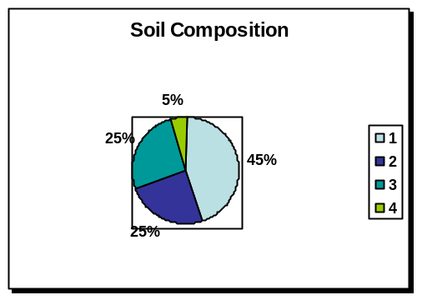
Refer to the graph - Match 1,2,3,4
with the four elements of soil.
Note the title of the graph
Note the data labels.

Using the information that we have studied today, write a short piece no more than 12 sentences long on the four elements of soil.
Soil Characteristics

There are 6 major characteristics (qualities) of soils

- Colour
- Structure
- Texture
- Organic Content (Humus)
- PH Value (Acidity)
- Water (Content and Retention)

We will study and learn three in detail – Texture, Structure, Water Content and Retention.

Texture of Soils

- The texture refers to the smoothness of coarseness (roughness) of soil. The texture depends on the size of the soil particles, which effects the pore space or gaps between the soil particles.
- The different pore spaces mean that soils will have different
  - Aerations (Amount of Air)
  - Drainage (water passing through)

There are three main textures –
Sandy Soils
- Rough/coarse and loose textures
- Large pores between particles so air and water can pass through them
- Little waterlogging so the particles don’t stick together
- Leaching of nutrients can occur and during a dry spell there may be a shortage of water
Clay Soils
- Smooth with small soil particles and are packed closely together (tight fitting)
- Very tiny pores so they prevent water and air passing through them
- Waterlogged in winter due to heavy rain (heavy/sticky) and hard, dry cracked surfaces in summer
- High in nutrients as leaching does not happen easily
Loam Soils
- Form from roughly equal amounts of sand and clay particles
- Moderate pore sizes allow enough air and drainage
- They usually don’t become waterlogged in winter or too dry in summer
- Light soils and high in nutrients so ideal for agriculture.

Structure of Soils
- Soil structure describes how soil grains are lumped or cemented together by Humus and Water
- The grains of soild are in small lumps called PEDS.
- The structure of the soil depends on the shape of the peds
- The spaces (pores) between the peds allow the soils to hold air and water or let air and water through
- The main soild structure are – Crumb (granular) allow air and water to pass through – Platy where the peds are flat and overlap and prevent water from passing through (waterlogging occurs)

Water Content and Retention
- The amount of water in a soil or the amount of water a oil can retain depends mainly on:
- Texture
  - Coarse sandy soils have large pores so they allow to pass through (little retention)
  - Small grained clay soils don’t allow water to pass through so they are poorly drained

- Structure
  - Crumb structures allow water to pass through, so they can dry up quickly
  - Platy structures restrict water movement so they have a large amount of water
- Humus – Soils rich in humus can hold more water than those with a low humus content

So far we have learnt a lot about soil and the questions that are asked in this Elective.
How many essay questions are on the paper? ________________ How many do you answer?_______
How many marks are there for each essay?____________________
Name four components of soil._______________________________________________________
Name four characteristics of soil _____________________________________________________
Which soil has the most desirable texture ______________. Why is this__________________________ _______________________________________________

Today we are going to learn two things 1 Factors Affecting Soil Formation. 2 The Factors that influence the characteristics of soil
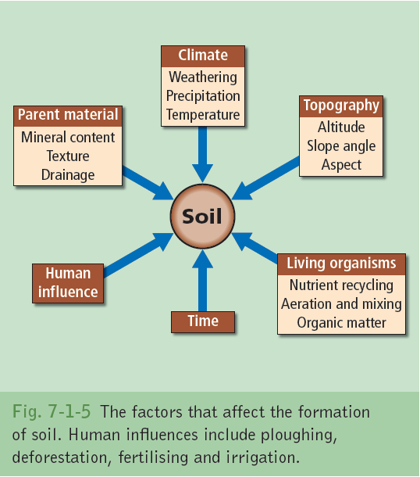
1 Factors Affecting Soil Formation

Soil is produced by the interaction of six major factors –
- Parent Material
- Climate
- Relief
- Organisms
- Time
- Human Influence (study later)

1 Parent Material
- The first stage in the formation of soils is the physical weathering of parent rock to give a layer of loose, broken rock called regolith.
- Parent material can come from a number of sources. These include River Alluvium, Glacial deposits including boulder clay, sand and gravel and volcanic material such as lava and ash.
- Parent material supplies minerals for the development of soil.
- Soils retain features of the original parent material therefore producing soils of different mineral content, depth, quality, acidity and texture.
  - Sandstone soils – Sandy and free draining
  - Shale – High clay content – badly drained
  - Limestone – Alkaline and have high PH

2 Climate
- The two components of climate temperature and rainfall have a major influence of the formation of soil on a global scale.
- Climate affects the rate of parent rock weathering and the most rapid breakdown of parent rock into minerals occurs in the hot, wet and humid equatorial and tropical regios where chemical weathering is very rapid.
- Mechanical weathering as more prevalent in regions of colder climates.
- Colder regions can be frozen for long periods of the year thus reducing the amount of vegetation on the soil and the rate of breakdown of organic matter into humus.
- Rainfall amounts influence the type of vegetation that grows – influences creation of humus
- Regions where there is heavy rainfall have most leaching causing acidic soils.
- A combination of rainfall and hot climates speeds up the decay of vegetation.

3 Relief
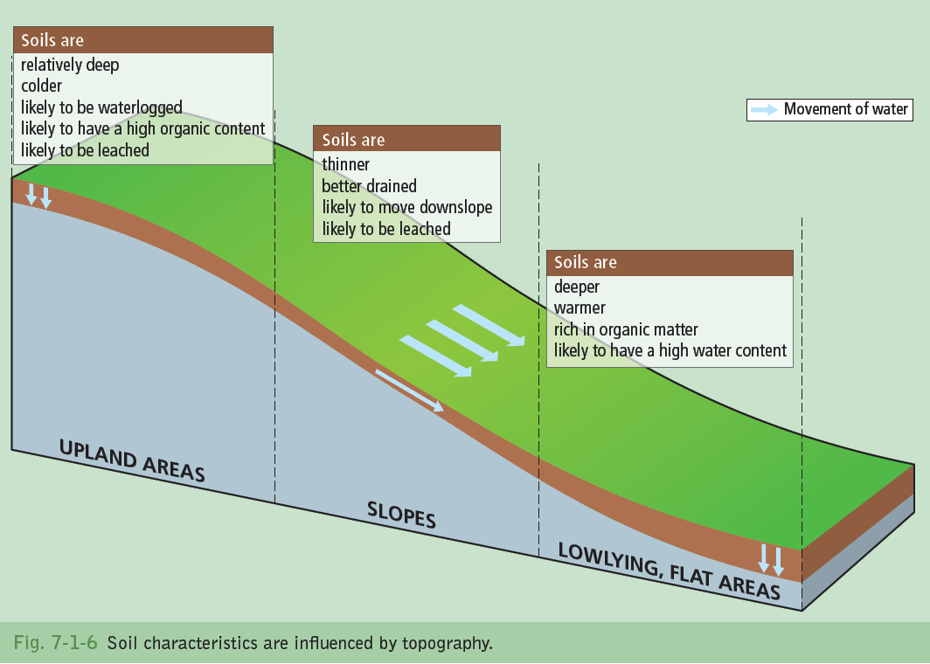
- Height of the land determines clouds and rain, temperature and growing season.
- Flat upland areas get waterlogged due to the slow rate of movement of water
- Peat soils develop due to the non conversion of dead organic matter into humus caused by low temperatures.
- Sloping land is usually well drained and dry.
- Risk on sloping land of soil creep as soils are thin.
- Lowlying flat areas have deeper soil. The area is warmer so that humification can take place and the soils are richer and more fertile.
- Sometimes lowlying areas can be waterlogged and boggy due to rainwater collecting at the bottom of slopes

The Processes/Factors that influence the characteristics of soil

Processes occurring within soils produce difference in
Texture, Structure, Colour, Ph Value etc.
Major processes are
- Leaching and Podzolisation
- Laterisation
- Humification
- Weathering
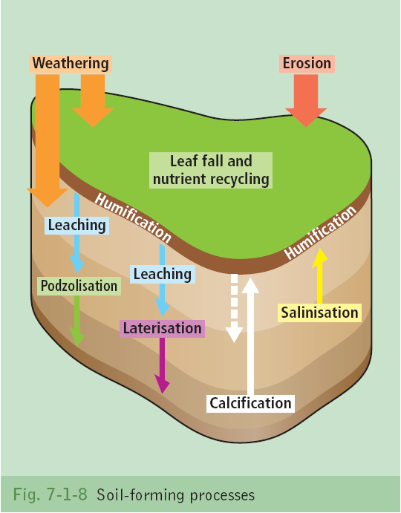

- Leaching and Podzolisation
  - Leaching occurs when heavy rainfall percolates down through the soil
  - Washing soluble substances down through the soils
  - Dissolving minerals and humus from the upper layers
  - Though leaching is needed to bring humus to lower layers it is often so great that the nutrients are brought so far down in soils out of the reach of roots – making soils infertile.
  - This can happen in sandy soils due to the nature of their texture as they are grainy and loosely packed,
  - Podzolisation is term that means regional leaching. That is leaching over an area
    - Can occur in areas of heavy rainfall eg. Irish Mountains
    - Can occur in areas where there is a large amount of humic acid in the soil eg under bogs or coniferous forests
    - Humic acid reacts with the rainwater making it acidic so that it dissolves most of the soil nutrients making soils infertile.

- Laterisation
- Leaching in the extreme that happens in equatorial and tropical regions due to a combination of
  - Heavy Rainfall and High Temps
- The heavy rainfall is the most important factor as it washes nutrient through the soil.
- The high temperatures speeds up chemical reactions between water and the minerals eg. Iron in the soil from the parent rock is broken down into iron oxide or rust.
- This iron oxide colours the soil a red and rusty colour. These soil are called Tropical Red Soils.

- Humification
- Humification is the process by which nutrients are added to the soil from dead organic matter.
- Micro organisms such as bacteria and fungi in soil break down the organic matter to a nutrient rich black gel.
- Oxygen in the soil also breaks down organic matter into humus.
- Rain washes the humus into the soil and the nutrients are used by the plant roots.

- Weathering
Weathering is a process that influences the characteristics of soil.
- Weathering of the parent rock produces the mineral content of the soil. This is the largest component of soil.
Mechanical and Chemical weathering produce the mineral content of soil.
- Freeze thaw actions breaks down rocks into minerals in mountainous regions
Chemical weathering such as carbonation causes calcium carbonate in limestone to dissolve

Question – Examine natural processes which influence soil formation. Use notes above supported by 156/157 Take three minimum processes and develop three paragraphs in your essay. Each paragraph needs to contain a minimum of six SRP’s. This is a step on the way to approaching this type of question.

Practice Run Essay Preparation

Para 1 – Process Name _____________________________

SRP 1___________________________________________________
SRP 2___________________________________________________
SRP 3___________________________________________________
SRP 4___________________________________________________
SRP 5___________________________________________________
SRP 6___________________________________________________

Para 2 – Process Name _____________________________

SRP 1___________________________________________________
SRP 2___________________________________________________
SRP 3___________________________________________________
SRP 4___________________________________________________
SRP 5___________________________________________________
SRP 6___________________________________________________

Para 3 – Process Name _____________________________

SRP 1___________________________________________________
SRP 2___________________________________________________
SRP 3___________________________________________________
SRP 4___________________________________________________
SRP 5___________________________________________________
SRP 6___________________________________________________

Just a quick reminder of what you have learnt already on this section list 4 Factors Affecting Soil Formation ________________________________________________________________________
List three Factors that influence the characteristics of soil.__________________________________
What is leaching?__________________________________________________________________
What is extreme leaching called?_______________________________________________________

By the end of today’s classes you will be another major step towards this final section of the paper. Today we are going to learn about Soil Profiles and the General Classification of Soils and how all of the components we have studied to date come together with an example of soil type
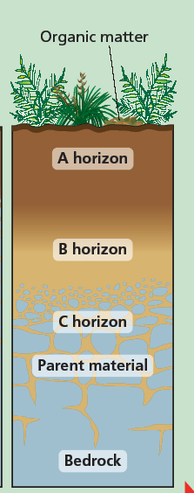
Soil Profiles
A soil profile is a vertical section through the soil from surface to bedrock
The Soil profile usually shows different layers in the soils
These layers are called horizons are there are usually four horizons in a soil profile.

The O horizon is on the surface which usually has – A large amount of organic matter, micro-organisms and humus in the lower part.

The A horizon is topsoil which has a mixture of minerals and organic matter, large amount of roots from vegetation and is dark in colour.

The B horizon called subsoil with percolating rain water, leached materials

The C horizon (regolith) with weathered parent materials (minerals).

General Classification of Soils

World soils maps do not always show the soils as they exist in reality – they show the soils as it is most likely to occur.

As climate is the most important factor in soil formation as they affect the soil forming processes and influence the amount of biological activity in soil – world soils are classified firstly according to climate.

The soils which develop in response to climatic conditions are called zonal soils they are found in particular climatic regions.
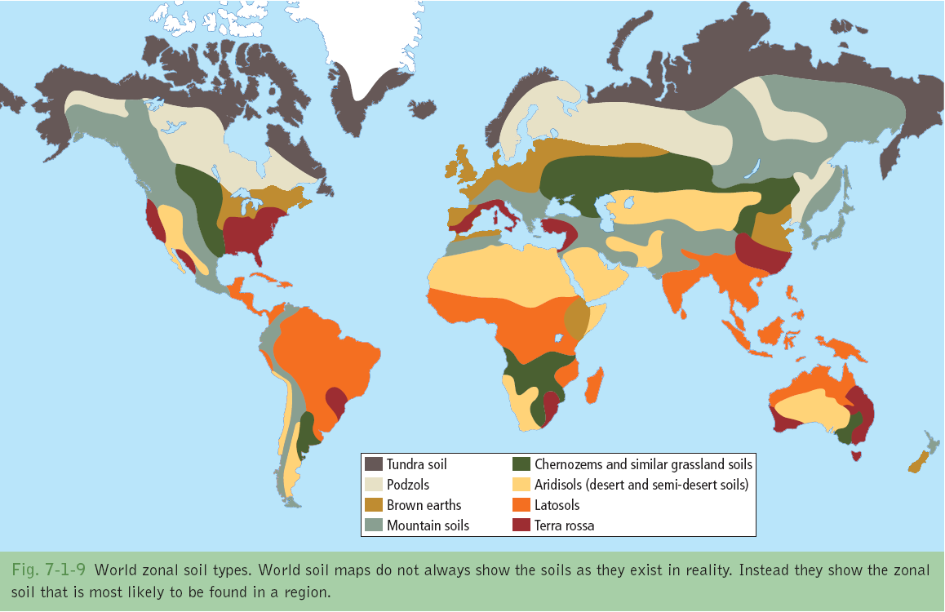
In climatic zones there are local differences due to differences in relief either upland or lowland
local climates (micro-climates), drainage, parent rock materials these produce local soils called intrazonal soils.
Example of a zonal soil – Brown Earth – Divided into Three Distinct Areas

Part One Soil Characteristics
- Brown earths are a zonal soil. They are found in temperate latitudes 40˚-60˚ North of the Equator
- The climate is normally cool temperate oceanic, they are a common soil in Ireland. Eg. NE Ulster and SE Leinster.
- Most brown earths have a crumb texture and this means that pore spaces are provided for air and water.
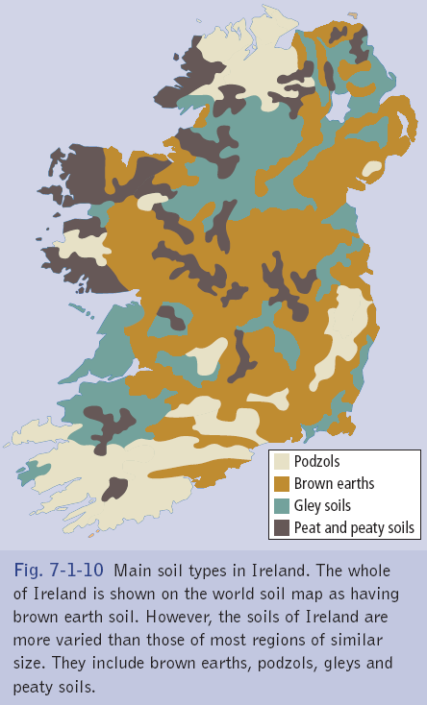
- The PH of brown earth can vary from slightly alkaline to slightly acidic (ranging from 5-7 on PH readings) and as acidity levels control which plants and animals will live in the soil there are local variations of plant/animal life.
- Brown earths usually have a dark brown colour throughout their soils profile as they contact a large amount of humus.
- Brown earths are usually very fertile as humus is composed of dead plants and animals and rainfall washes the humus into the soil and it is used by plant roots as nutrients.
- Brown earths are well drained and water can pass through them. The humus content ensures that they can hold moisture.
- Structurally, brown earths are a loam soil equally composed of sand silt and clay. It remains free from waterlogging and is good for agriculture.
Part Two The Processes/Factors that influence the characteristics of soil
- The factors or causes of the characteristics of brown earths are the usual ones for zonal soils.
- The cool temperate climate allowed the growth of dense deciduous forests. The trees (oak, beech) and the dense undergrowth provided larger amounts of plant litter for the development of humus in the soil.
- The cool temperare climate is warm enough for biological activity and micro-organisms (bacteria and fungi) and animals such as earthworms are present for activity to occur for more than nine months of the year.
- The microorganisms break down the plant litter to form humus which gives the soils its crumb texture, brown colour and fertility.
- The crumb texture and the burrowing animals provide pore spaces for water and air to help plant growth and fertility.
- There is enough rainfall all year round to provide a little leaching and this limited leaching mixes the soil and washes nutrients into the soil.
- Irish brown earths can vary from slightly alkaline to slightly acidic and this helps the activities of earthworms, fungi and bacteria to decompose the humus and mix the nutrients.
- The parent materials for Irish brown earths range from limestone, granite, and glacial boulder clay.
- Usually brown earths develop in relief areas with gentle slopes allowing the free draining of water in the soil. Combined with the warmer temperatures this helps the development of humus.
Part Three Soil Profile

Homework, use the information below to create 8 SRP’s referring to the four horizons, referring the colour of the soil. Remember the SRP’s need to hold together to create a cohesive and well written piece.
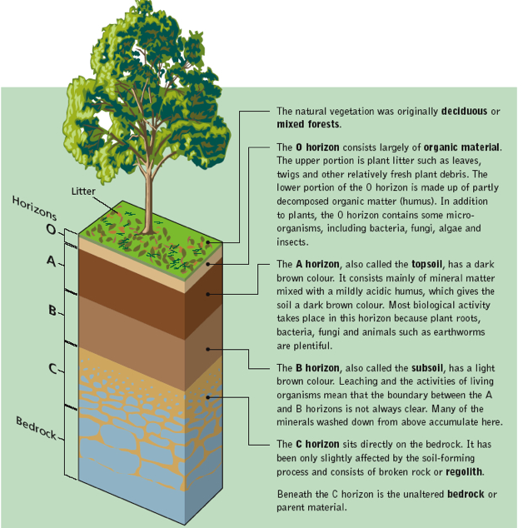

Human Influences affecting Soil
Example of Sahel – Africa

Human Influences in the Sahel region have led to desertification of the land. There are reports to suggest that the Sahara Desert is advancing southwards by between 5-10 km per year. The Sahel is a band of land that is traditionally covered by grassland and supports a nomadic society that followed the rains. It is semi arid, wet season from June to September.

Refer to page 163 – Fig 7-1-13

Over-cropping

- Over-cropping sometimes called over cultivation impacts on soils erosion and degradation

- Over-cropping occurs when people use the land year after year without
  - Practicing Crop rotation
  - Resting it or leaving it fallow
  - Renourishing the soil through fertilizers

- In the Sahel region of Africa (Mali, Chad) increasing population pressure and the need to repay loans has increased over-cropping because all the land is needed year after year and the soild cannot be left fallow to regain nutrients

- People are so poor they cannot afford to purchase and use artificial fertilizers to improve soil fertility.

- The development of plantation farming for cash crops (cotton, nuts) to repay debts has led to mono culture growing the same crop each year on the same piece of land. This uses up the same soil nutrients each year.

- The repeated deep ploughing needed to allow planting of the crops destroys the soil structure by breaking up the peds and burying organic matter too deep for plant use.

- Deep ploughing also loosens the topsoil for future water and wind erosion – loose dry topsoil is blown away by the wind as happens in Mali.

- The need for large amounts of irrigation water each year to keep the land famed continuously has led to the problem of salinisation in the hot, dry climates of Mali and Ethiopia. Salinisation is the accumulation of soluble mineral salts near the surface of the soil. Evaporation of water leaves soluble salts close to the surface of the soil. The excess water from irrigation raises the water table and brings salt to the surface. The hard, white crust prevents nutrients entering the soils.

- Over-cultivation causes the soils to become so lacking in minerals that the soils soil is :
  - Left without protective cover as vegetation won’t grow
  - Removed by wind and water erosion

Over-grazing

- Over-Grazing occurs when the farmers allow too many animals to graze an area of land. So much vegetation cover is removed that the animals:
  - Remove vegetation exposing the soil
  - Destroy the soil structure

- The need for an assured water supply attracts many migrant people and their animals. Around many new water-wells sunk in the 1980’s in Kenya overgrazing has occurred due to increased numbers of cattle removing trees and grass, thus exposing the soil to erosion.

- In many African countries, eg. Kenya people measure their wealth in terms of the numbers of animals (cattle and goats) no the quality. So as the human population grows the number of farm animals increases also. This leads to the removal of grass and exposes the soil to soil erosion.

- The lack of vegetation of grass means that there is no interception of raindrops. This means that heavy rain falls directly onto the soil and loosens it.

- This leads to sheet erosion on slopes as the whole topsoil layer can be washed evenly down a slope. Eg. Ethiopian Highlands

- When new shoots of grass appear after the rains they are eaten immediately and when rain alls again there is no vegetation to absorb it and gully erosion occurs (small streams remove soil and cut into the soil surface)

- Grass roots bind the soil together but with no vegetation to bind it together soil is loosened and can be blown away (dry season) or washed away (wet season)

Deforestation

Final section refer to page 164

Write 8 SRP’s on Deforestation and you can mention Shelter belts as positive option

SRP 1___________________________________________________
SRP 2___________________________________________________
SRP 3___________________________________________________
SRP 4___________________________________________________
SRP 5___________________________________________________
SRP 6___________________________________________________
SRP 7___________________________________________________
SRP 8___________________________________________________

